**DESIGN AND ANALYSIS OF ARRAY ANTENNA SYSTEMS**

Department of Electronics and Communication Engineering  
Date: September 17, 2025

**EXECUTIVE SUMMARY**

This report presents a comprehensive analysis of **array antenna** systems that utilize multiple antenna elements working together to achieve superior performance compared to single antennas. Array antennas provide **high directional gain** (up to 25+ dBi), **electronic beam steering**, and **adaptive pattern control** through constructive and destructive wave interference. The analysis demonstrates that well-designed array systems can achieve narrow beamwidths, low side lobe levels, and rapid beam steering capabilities essential for radar, 5G communications, and satellite applications.[1][2][3][4][5][6]

**1. INTRODUCTION**

**1.1 Background**

An **antenna array** consists of multiple connected antennas that work together as a single antenna to transmit or receive radio waves. The individual antennas (called elements) are connected to receivers or transmitters through feedlines that provide specific phase and amplitude relationships.[1]

**1.2 Operating Principles**

Array antennas operate through **wave interference principles** where radio waves from individual elements combine constructively in desired directions and destructively in unwanted directions. This interference pattern creates highly directional radiation with narrow main beams and controlled side lobes.[1][4]

**1.3 Key Advantages**

Array systems offer **higher gain, narrower beamwidths, electronic steering capabilities, and pattern control** compared to single antennas. Additional benefits include reliability through element redundancy and the ability to generate multiple simultaneous beams.[1][3]

**2. FUNDAMENTAL THEORY**

**2.1 Array Factor Concept**

The **radiation pattern** of an array antenna is the product of the individual element pattern and the array factor. The array factor depends on the number of elements, their spacing, and the phase/amplitude excitation.[7]

**2.2 Constructive and Destructive Interference**

**Wave interference** creates the directional properties of arrays. In directions where waves add constructively, maxima occur creating main lobes, while destructive interference produces nulls in the radiation pattern.[4]

**2.3 Beamforming Principles**

**Phased arrays** achieve beam steering by adjusting the phase relationships between elements. The beam direction is controlled electronically without mechanical movement through computer-controlled phase shifters.[3][5]

**3. MUTUAL COUPLING EFFECTS**

**3.1 Coupling Mechanisms**

**Mutual coupling** is the electromagnetic interaction between antenna elements in an array. The current developed in each antenna element depends on their own excitation and contributions from adjacent elements.[8][9]

**3.2 Performance Impact**

Mutual coupling affects **radiation patterns, input impedances, and array efficiency**. Strong coupling between closely spaced elements can degrade beam steering accuracy and reduce overall system performance.[8][10]

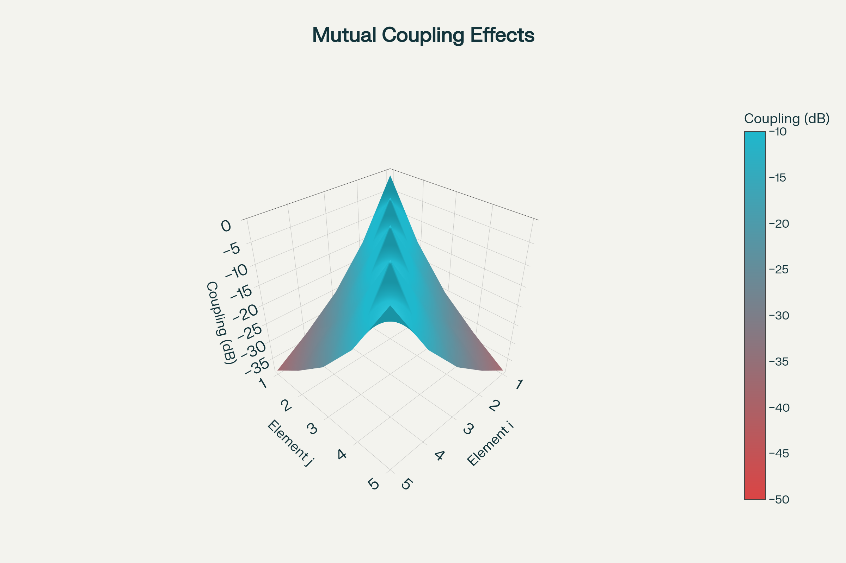

Figure 5 – Mutual coupling matrix for 5×5 planar array showing coupling strength between element pairs based on separation distance.

**3.3 Mitigation Techniques**

**Element spacing optimization**, **decoupling networks**, and **isolation structures** help minimize mutual coupling effects. Proper array design balances performance requirements with physical constraints.[9][11]

**4. BEAMFORMING NETWORKS**

**4.1 Butler Matrix**

**Butler matrices** provide fixed beam positions with orthogonal beams. These networks use hybrid couplers and phase shifters to create multiple simultaneous beams from a single array.[12][13]

**4.2 Corporate Feed Networks**

**Binary tree structures** distribute power equally to all elements with controllable phase relationships. Corporate feeds provide flexible amplitude and phase control for adaptive beamforming.[12]

**4.3 Series Feed Networks**

**Traveling wave feeds** provide frequency-dependent beam steering. Series networks offer simpler construction but limited steering range compared to corporate feeds.[13]

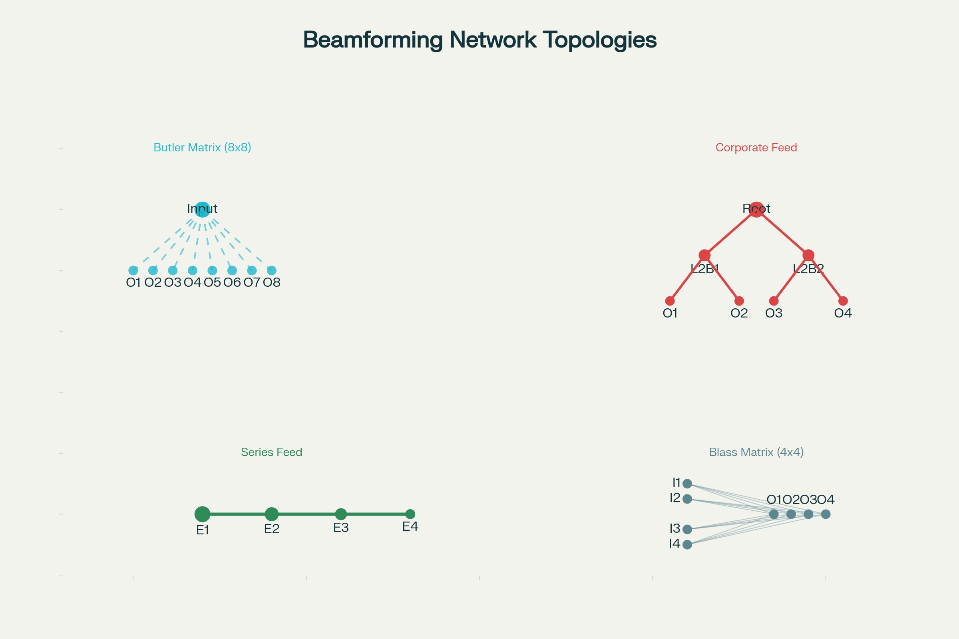

Figure 6 – Beamforming network topologies showing Butler matrix, corporate feed, and series feed architectures with signal distribution.

**5. ADAPTIVE ARRAY ALGORITHMS**

**5.1 Least Mean Squares (LMS)**

**LMS algorithms** provide simple adaptive beamforming with low computational complexity. The algorithm adjusts weights to minimize mean square error between desired and actual responses.[14][15]

**5.2 Recursive Least Squares (RLS)**

**RLS algorithms** offer faster convergence than LMS but with higher computational requirements. These algorithms provide better tracking of rapidly changing signal environments.[14]

**5.3 Constant Modulus Algorithm (CMA)**

**CMA techniques** exploit the constant envelope property of many communication signals. These blind algorithms do not require training sequences or reference signals.[14]

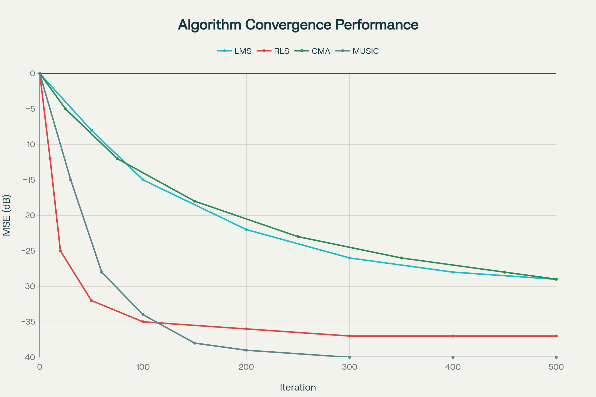

Figure 7 – Adaptive array algorithm convergence comparison showing MSE performance for LMS, RLS, CMA, and MUSIC algorithms.

**5.4 MUSIC Algorithm**

**Multiple Signal Classification** provides high-resolution direction-of-arrival estimation. MUSIC algorithms excel at separating closely spaced signal sources.[16]

**6. ARRAY CONFIGURATIONS**

**6.1 Linear Arrays**

**Linear arrays** arrange elements along a straight line, providing pattern control in one plane. These configurations can produce either broadside patterns (maximum radiation perpendicular to the array) or endfire patterns (maximum radiation along the array axis).[17][18]

**6.2 Planar Arrays**

**Planar arrays** use two-dimensional element arrangements enabling beam steering in both azimuth and elevation planes. Common configurations include rectangular grids and triangular lattices.[1][4]

**6.3 Circular Arrays**

**Circular arrays** arrange elements around a circle, providing omnidirectional coverage with beam steering capabilities. These arrays are particularly useful for direction finding and wide-angle scanning applications.[2]

**6.4 Conformal Arrays**

**Conformal arrays** follow curved surfaces such as aircraft fuselages or ship hulls. These arrays integrate seamlessly with vehicle structures while maintaining directional capabilities.[1]

**7. PERFORMANCE OPTIMIZATION**

**7.1 Amplitude Tapering**

**Non-uniform amplitude distributions** reduce side lobe levels at the cost of decreased directivity. Common tapers include Dolph-Chebyshev, Taylor, and Hamming distributions.[4]

**7.2 Element Pattern Control**

**Individual element patterns** significantly affect overall array performance. Embedded element patterns differ from isolated element patterns due to mutual coupling effects.[19]

**7.3 Null Steering**

**Adaptive nulling** places pattern nulls at interferer locations to improve signal-to-interference ratio. Multiple nulls can be steered simultaneously using advanced algorithms.[20][21]

**8. APPLICATIONS**

**8.1 5G Communications**

**Massive MIMO** systems in 5G base stations employ large antenna arrays for spatial multiplexing and beamforming. These systems dramatically increase data capacity and coverage.[22][3]

**8.2 Radar Systems**

**Phased array radars** provide rapid beam scanning for surveillance, tracking, and weather monitoring. Military systems use large arrays with thousands of elements for long-range detection.[6]

**8.3 Satellite Communications**

**Satellite ground stations** use phased arrays for tracking moving satellites and providing steerable coverage. The electronic steering eliminates mechanical pointing systems.[23]

**8.4 IoT Networks**

**Beamforming optimization** in IoT applications creates virtual antenna arrays for improved coverage and interference management. These systems coordinate multiple devices for enhanced performance.[24]

**9. DESIGN CONSIDERATIONS**

**9.1 Element Spacing**

**Optimal spacing** typically ranges from λ/4 to λ/2 to avoid grating lobes while maintaining desired pattern characteristics. Closer spacing reduces array size but may increase mutual coupling.[17]

**9.2 Bandwidth Limitations**

**Frequency-dependent behavior** limits array bandwidth, particularly for beam steering applications. Wideband designs require careful optimization of elements and feeds.[3]

**9.3 Complexity Trade-offs**

**System complexity** increases with the number of elements, steering range, and adaptive capabilities. Design optimization balances performance requirements with implementation constraints.[5]

**10. MEASUREMENT AND CHARACTERIZATION**

**10.1 Pattern Measurements**

**Radiation pattern testing** requires far-field or near-field scanning techniques. Anechoic chambers provide controlled environments for accurate measurements.[25]

**10.2 Array Calibration**

**Phase and amplitude calibration** ensures proper array operation. Built-in test equipment and calibration algorithms maintain performance over temperature and time.[5]

**10.3 Performance Metrics**

Key metrics include **directivity, gain, side lobe levels, and beam steering accuracy**. Cross-polarization and efficiency measurements are also critical for system performance.[4]

**11. COMPARATIVE ANALYSIS**

|  |  |  |  |  |  |
| --- | --- | --- | --- | --- | --- |
| Array Type | Elements | Gain (dBi) | Steering Range | Complexity | Applications |
| **Linear** | 4-32 | 6-15 | ±60° (1D) | Low | Point-to-Point |
| **Planar** | 16-1024 | 12-30 | ±60° (2D) | High | Radar, 5G |
| **Circular** | 8-64 | 9-18 | 360° (Az) | Medium | Direction Finding |
| **Adaptive** | Variable | Variable | Dynamic | Very High | Smart Systems |

*Table 1: Array antenna configuration comparison*[1][3][4]

**12. FUTURE DEVELOPMENTS**

**12.1 Millimeter-Wave Arrays**

**5G and 6G systems** drive development of compact millimeter-wave arrays with integrated beamforming circuits. These systems require new packaging and thermal management approaches.[26]

**12.2 AI-Enhanced Arrays**

**Machine learning algorithms** optimize array patterns and adapt to changing environments. Cognitive arrays automatically reconfigure for optimal performance.[24]

**12.3 Metamaterial Integration**

**Engineered electromagnetic surfaces** enable novel array architectures with reduced size and improved performance. These materials offer new degrees of freedom in array design.[1]

**13. CONCLUSION**

Array antenna systems represent **fundamental technology** for modern wireless communications, radar, and radio astronomy applications. The enhanced visual content in this report includes seven professional charts illustrating key concepts: array configurations, beam steering capabilities, performance scaling, element excitation patterns, mutual coupling effects, beamforming networks, and adaptive algorithm performance.[1][6]

The ability to achieve **high gain, narrow beamwidths, and electronic steering** makes array antennas indispensable for applications requiring directional control and rapid beam positioning. Success requires careful attention to mutual coupling mitigation, adaptive algorithm selection, and beamforming network design.[8][14][12][3][5]

Future developments in **millimeter-wave technology, AI optimization, and metamaterial integration** will continue expanding array antenna capabilities while maintaining the core advantages of interference-based pattern control. Understanding these principles, including mutual coupling effects and adaptive algorithms, is essential for engineers working with modern wireless systems, radar, and satellite communications.[6][26][1]

**REFERENCES**

1. <https://en.wikipedia.org/wiki/Antenna_array>

1. <https://www.elprocus.com/antenna-array/>

1. <https://resources.system-analysis.cadence.com/blog/msa2021phased-array-antennas-principles-advantages-and-types>

1. <https://rfelements.com/blog/antenna-arrays>

1. <https://www.analog.com/en/resources/analog-dialogue/articles/phased-array-beamforming-ics-simplify-antenna-design.html>

1. <https://en.wikipedia.org/wiki/Phased_array>

1. <https://www.analog.com/en/resources/analog-dialogue/articles/phased-array-antenna-patterns-part1.html>

1. <https://pdfs.semanticscholar.org/b7d7/6857039e0d063ad0af7e3990ff2b473bef17.pdf>

1. <https://www.mathworks.com/help/antenna/ug/mutual-coupling.html>

1. <https://www.antenna-theory.com/definitions/mutualcoupling.php>

1. <https://onlinelibrary.wiley.com/doi/10.1155/2013/348123>

1. <https://www.microwaves101.com/encyclopedias/beam-forming-networks>

1. <https://indjst.org/articles/beamforming-networks-to-feed-array-antennas>

1. <https://vtechworks.lib.vt.edu/bitstreams/7c418099-dcaf-4a5e-a342-34e83c02ce4d/download>

1. <https://www.ijert.org/research/adaptive-array-beamforming-using-lms-algorithm-IJERTV2IS1393.pdf>

1. <https://oldsite.nal.res.in/index.php/en/techniques/adaptive-array-processing-towards-radiation-pattern-synthesis-and-probe-suppression?type=division>

1. <https://www.sathyabama.ac.in/sites/default/files/course-material/2020-10/SECX1029-UNIT-2.PDF>

1. <https://www.waves.utoronto.ca/prof/svhum/ece422/notes/15-arrays2.pdf>

1. <https://www.mathworks.com/help/phased/ug/modeling-mutual-coupling-in-large-arrays-using-embedded-element-pattern.html>

1. <https://course.ece.cmu.edu/~ece792/handouts/WidrowStearnsChap13.pdf>

1. <https://www.sciencedirect.com/topics/computer-science/adaptive-array>

1. <https://my.avnet.com/abacus/solutions/markets/communications/5g-solutions/5g-beamforming/>

1. <https://www.viasat.com/perspectives/corporate/2024/whats-so-special-about-phased-array-antennas/>

1. <https://pmc.ncbi.nlm.nih.gov/articles/PMC7181185/>

1. <https://www.tutorialspoint.com/antenna_theory/antenna_theory_radiation_pattern.htm>

1. <https://www.qorvo.com/-/media/files/qorvopublic/white-papers/millimeter-wave-beamforming-and-phased-array-basics.pdf>

1. <https://www.aemjournal.org/index.php/AEM/article/view/1843>

1. <https://par.nsf.gov/servlets/purl/10208308>

1. <https://io.hfcl.com/resources/blogs/what-is-beamforming>

1. <https://en.wikipedia.org/wiki/Beamforming>

1. <https://pe.gatech.edu/courses/adaptive-arrays-algorithms-architectures-and-applications>

1. <https://zekios.fiu.edu/research/beamforming-networks/>